exempt, unincorporated, private, American
Non-Statutory Trust - Workable Template

jus soli, Lawful Person, Legal Person, & COMMERCIAL PERSON

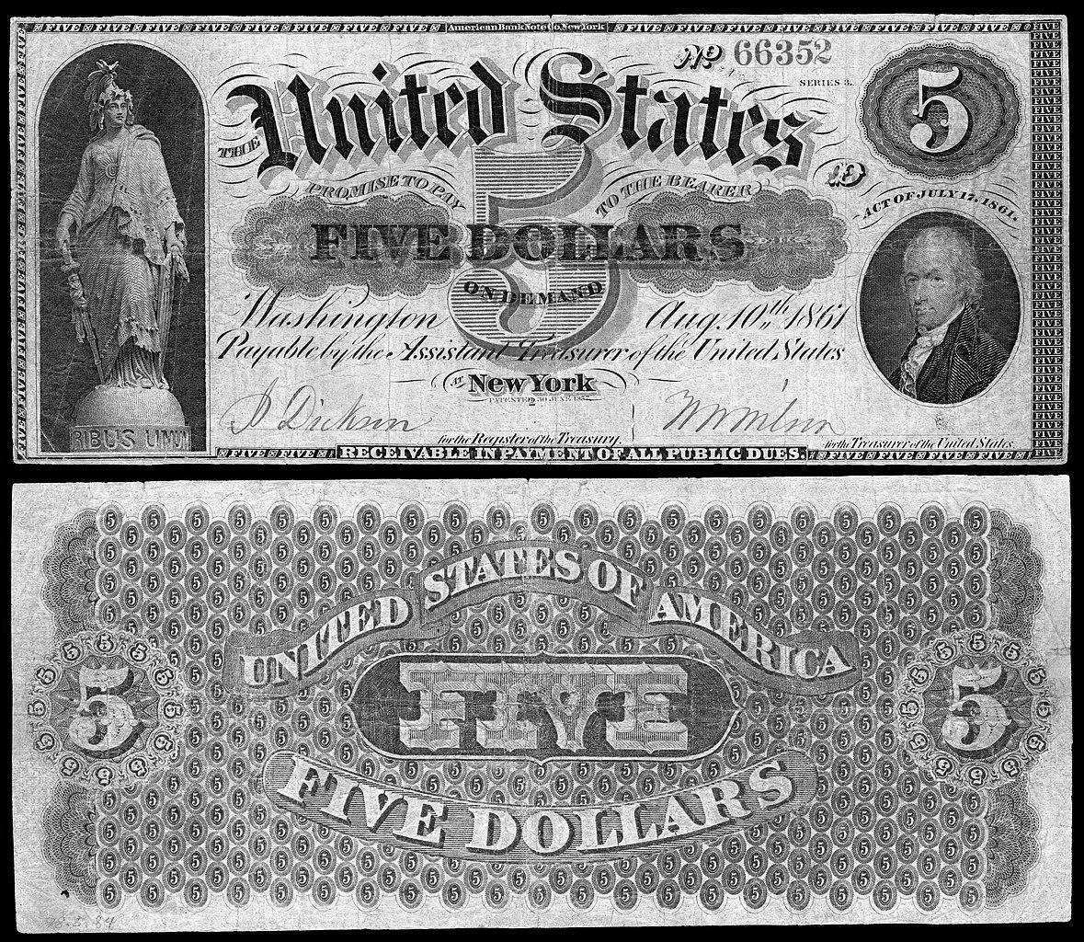

Welcome to Your Non-Statutory Trust Template
- By correcting one's political status to an American State National you have shifted your “COMMERCIAL PERSON(S)” “Legal Person(s)” and “Lawful Person(s) back to the Land of your “born” nation-state / State of Union - AND - out of previously domiciled foreign jurisdiction.
- By taking this action these “vessels” are all now considered American and owed all Constitutional Guarantees and Protections along with your American Common Law Copyright.
- It is our belief that this is one of the keys to creating a true Non-Statutory Trust and provides a long lost layer of protection to defend against risk and exposure from across the BAR - privateers, outlaws, and modern day pirates.
- Now comes the interesting thought experiment to consider if there is a unique way to “name” the Donor/Creator, Trustee, and Beneficiary parts of a trust.
- Think of a trust similar to a corporation - Donor/Grantor = The Board. Trustee = Managers and employees. Beneficiary = Shareholders.
- Consider that the Donor/Creator of your trust must be either your “jus soli”-all lowercase name like john quincy adams or your Lawful Person-upper and lowercase name like John Quincy Adams.
- IMPORTANT to consider, only living men/women or Lawful Person(s) are able to own private property like land, diamonds, silver, gold etc - so in order to donate, create, or move real property to trust one must be operating in one of these 2 capacities.
- Legal Person(s) can act as trustees for Lawful Person(s) due to the fact that in a trust declaration the trustee does not own anything but does manage the trust assets for the benefit of the beneficiaries.
- This is a key fact to know in order to create a clear separation between the Trustee and both the Donor/Creator AND Beneficiary. “Own Nothing and Benefit from Everything.”
- The Donor/Creator can be the same as the Beneficiary as long as there is no working connection or oversight of the Trustee and the decisions of the Trustee..
- In knowing this the names to consider in completing your Trust Declaration and what “role” they are in are important to consider.
  - john quincy adams (jus soli / man of the soil - National Soil Jurisdiction)
  - John Quincy Adams (Lawful Person - International Land Jurisdiction)
  - John Quincy Adams (Legal Person - International Sea Jurisdiction)
  - JOHN QUINCY ADAMS (Commercial Person - Global/Air Jurisdiction)
  - Maybe your Lawful Person is the Donor, your Legal Person is the Trustee, and your Jus Soli is the Beneficiary.
  - Or… some combination of this grouping and/or in combination with a Trustee that is a friend that has corrected their status to the Land and Soil so the Trust can be domiciled on the Land and Soil of where the Trustee lives.
  - This creative thought experiment leads to many interesting options to consider for overall creation purposes.

Trust Name and Creator
- What’s in a name? Your type of business, geographic location, a brand, etc. There are no restrictions. Is there a perception you wish to influence?
- For privacy, OMIT personal information such as full names. Initials can be ok. Examples: Western Properties, Prestige Aviation, Z.L. Investments, Finanza Medici XVII, Acme Products Company. You must not use the word incorporated, corporation or Inc because that is misrepresentation. however you may use the word 'company.’ Once you decide the name for your Business Trust, write it down. You will need this information in order to fill out the Business Trust Declaration:

Trustees, Domicile & Address

- Who is/are your trustee(s)? An entity, an individual or multiple persons. Trustees hold legal title to assets such as bank accounts and real estate. Examples: John Smith as Trustee, or John Smith and Lorena Martinez as Co-Trustees
- What is a domicile? This is where your trust is permanently based. It is typically the state where your trustee resides.
  - Consider the style of the city/City/CITY, state/State/STATE and address information when indicating the “address” of the Trustee.
  - Similar to the differences between the Jus Soli, Lawful Person, Legal Person, and COMMERCIAL PERSON the style of the data points in the address can potentially change the domicile of the Trust.
  - For example - texas = National Soil Jurisdiction, Texas = International Land and Sea Jurisdiction, TEXAS = Global/Air Jurisdiction.
  - We also recommend you consider placing any “zip code” in brackets like this - [61604].
  - 2228 west auburn avenue, clayton, arizona, [67890]
  - 2228 West Auburn Avenue, Clayton, Arizona, [67890]
  - 2228 West Auburn Avenue, Clayton, Arizona, 67890
  - 2228 WEST AUBURN AVE, CLAYTON, AZ, 67890
  - Note that each style of the “address” can indicate a domicile that potentially makes the Trust more or less susceptible to attack depending on the jurisdiction of where trust is domiciled.
- List the domicile for your Business Trust. You will need this information in order to fill out your Business Trust Declaration:
  - Your Trustee can use a P.O. Box for the mailing address and if you need a physical address you can use the mailing address of the post office where the P.O. Box is housed.
- If desirable, you can later move your domicile by changing to a trustee in another state. Your existing trustee resigns and the new one is appointed.

Beneficiaries

- Who are your beneficiaries? (also called shareholders) They receive the income or profits from the business trust.
- Your shares begin with 100 units (or 100%). They are owned by a single beneficiary or divided among multiple beneficiaries.Examples: John Smith, Kay Martinez Living Trust*, Italia LLC, John Smith children, etc.
- ​Write down the name of the beneficiaries of the Business Trust and the amount of units assigned to each one of them. You will need this information in order to complete Schedule C on your Business Trust Declaration.
- Consider the style of the “name” you enter for the Beneficiary.
EIN - Employer Identification Number

- Consider only needing an EIN if and when you need a banking account.
- Consider the Trustee being the one that creates the EIN and operates the banking account for the Trust.
- Consider using only the Sole Proprietor option for EIN purposes to be declared as an unincorporated association account for banking purposes at your financial institution/bank/credit union.
- Your Business Trust is NOT a “trust” on EIN Application.
- Consider the significance of the Trustee operating as a Sole Proprietor for EIN purposes and how this creates a natural separation from Donor and Beneficiary further strengthening the fact that there is NOT a working relationship or oversight of the Trustee by the Donor or Beneficiary.
- This further strengthens the fact that your Trust is a Non-Statutory Business trust.
- One additional point to consider and explore is the Foreign National option for EIN purposes.
- Remember in the Federal System, American State Nationals are Foreign National(s) with respect to the Federal/ “Contract” government.

